|  |
| --- |
| Quarterly Public Health Report |
|  |

|  |  |
| --- | --- |
| October-December 2019 | Quarter 3 |

Quarterly Public Health Report

Quarter 3

# Introduction

Welcome to quarter 3 public health report. The report outlines key activities within quarter 3 of 19-20 (October to December), within the areas of health improvement, public health commissioning, health intelligence, health care public health, and health protection. This quarter there is a report on how we use the public health grant.

# The Public Health Grant

In 2018/19, the PH grant was £10.523m. The grant is used to fund the mandated elements;(the 0-19 Public Health Nursing service, National Child Measurement Programme, NHS Healthchecks, Sexual Health services); discretionary but recommended services (Drug and Alcohol services); staffing; health improvement projects and work on the wider determinants of health.

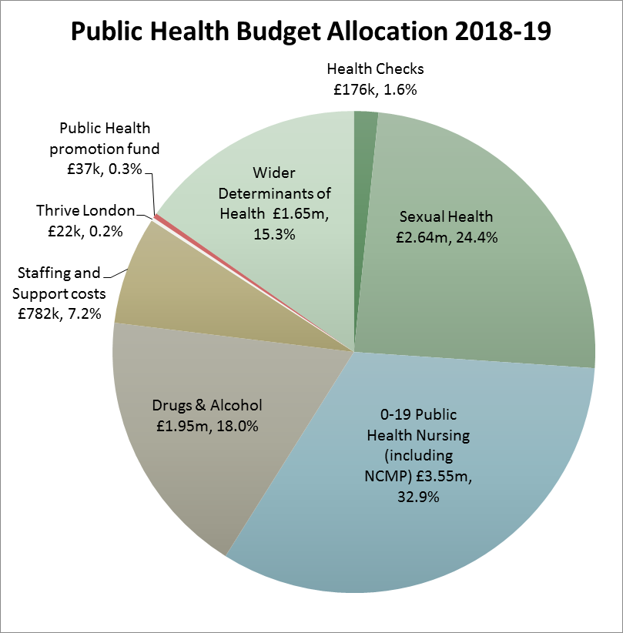

In other quarters, we report on the different programmes within the remit of the public health team. This quarter, we are focusing on the use of the grant with respect of the wider determinants of health.

## What do we mean by the Wider Determinants?

Wider determinants, also known as social determinants, are a diverse range of social, economic and environmental factors which impact on people’s health. These factors are influenced by the local, national and international distribution of power and resources which shape the conditions of daily life. They include factors like socioeconomic status, education, neighbourhood and physical environment, employment, and social support networks, as well as access to health care.

There is a social gradient across many of these determinants that contribute to health with poorer individuals experiencing worse health outcomes than people who are better off. Children growing up in more deprived areas often suffer disadvantages throughout their lives, from educational attainment through to employment prospects, which in turn affect physical and mental wellbeing.

The reason we work on these wider determinants is to take upstream action to prevent the downstream health consequences.

## Grant Conditions

The public health grant is ring fenced and must therefore be spent in accordance with the grant conditions. In addition to the mandated and recommended services, the other areas of funding must:

* have a significant effect on public health
* provide value for money, and
* have regard to the need to reduce inequalities between the people in its area with respect to the benefits that they can obtain.

In 2018-19, adult services, children’s services, housing and economic development received funding through the public health grant.

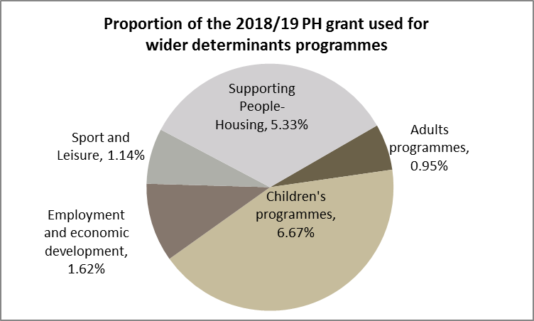

## Economic development

There is a wealth of evidence which shows the interrelationship between unemployment and poor health and low income and poor health. The public health grant funding has been used to develop referral routes into the Work and Health Programme, implement social value agreements with suppliers and employment and training plans with developers, develop funding bids to support low paid workers, develop and maintain operational links with housing, benefits and Peoples Directorate to ensure those most in need can access provision. In addition to the outcomes, funding of £480K has also been secured for upskilling. The work and health programme achieved 223 job outcomes of which 162 were sustained; 41 apprenticeships and 26 work placements.

## Housing related programmes

Housing is closely linked to health and wellbeing so helping people to access and maintain housing and preventing them from becoming homeless is an important public health action.

The public health grant is used to fund a number of housing related programmes. These programmes focus on supporting vulnerable people to reduce the impact on health inequalities. Vulnerable adults with support needs are at risk of needing more intensive, higher level and more expensive services if their needs are not met. Supported Housing is a way of meeting the housing needs and the low to medium support needs of residents and preventing them from needing other services, as well as addressing short term issues which have not been resolved effectively and act as barriers to independent living and wellbeing. Helping service users meet their support needs and improve their independent living skills contributes to their confidence and wellbeing.

### EACH Supported Housing and Floating Support

Two services are provided by EACH. The first is a floating support service and the second. is an accommodation based service that provides both housing and support to adults with substance misuse and/or offending. There are 6 units of accommodation at the scheme. Part way through the year the landlord decided to withdraw the properties from this arrangement and the service was changed to a specialist floating support service.

The purpose of a floating support service is to support service users to sustain their tenancy/housing and prevent homelessness through activities such as welfare advice, managing rent arrears, reporting repairs, considering housing options, entering volunteering/training/education/employment and accessing other services such as GPs, mental health services, drug and alcohol services.

### SSAFA supported housing

SSAFA provides a supported housing service called ‘Stepping Stones’. There are 20 units of accommodation and the Council funds 12 of these units. While the scheme is primarily intended to support women and their children from the Armed Forces community some of the spaces funded by the Council are used for homeless women and their children who do not have an Armed Forces connection.

Women of the Armed Forces community may find themselves without somewhere to live or require a place of safety. SSAFA's Stepping Stone home provides a comfortable, secure and female-only place to stay for as long as they need to get back on their feet (up to 2 years). The scheme has individual rooms and a range of communal areas.

While the scheme is not a domestic abuse refuge the women who access the service have often experienced domestic abuse.

The staff team provides information, advice, guidance and support

### Hestia domestic abuse services

Hestia provides a range of domestic abuse services commissioned by the council and this budget contributes to the funding of the domestic violence refuge and the floating support service. The refuge is a place of safety for any mother and child made homeless by domestic abuse. Hestia offers emotional and practical support and ensures that every service user has an up-to-date risk assessment and support plan tailored to their needs. There are 6 units of accommodation at the refuge.

## Supporting vulnerable adults

### Harrow User Group

The Harrow User Group (HUG) is a user run support group for residents of the London Borough of Harrow suffering with long term mental illness. HUG foster a mental health recovery model that helps to build the resilience of people with mental illness to promote: Around 350 people are registered with the HUG and 30-40 attend each meeting. HUG members are more likely than the Harrow average to be unemployed, reliant on welfare benefits, live in social housing or residential services, and be socially isolated. In addition 60% of the members are BMER (Black Minority Ethnic and Refugee).

### Rethink at The Bridge

The Bridge community mental health hub promotes recovery, rehabilitation and independence to people with mental health illness. It supports a diverse range of people to achieve their individual goals and outcomes through a variety of means tailored to each individual client. The Service operates in an innovative and resourceful way and encourages its users to be innovative and resourceful in their recovery.

### Age UK Befriending

The befriending scheme is aimed at those over 60 who are isolated or housebound, who have limited to no social contact on a week to week basis. It is a coordinated programme with a team of 35 volunteers who provide a befriending service for around 50 of the most socially isolated citizens in Harrow. Volunteers work on a one to one basis with individuals agreeing to reduce levels of isolation and loneliness, so improving health and wellbeing.

## Giving children a good start

### Early support hubs

Three early support hubs in Harrow provide a wide range of activities and services including stay and play for social development, healthy eating, readiness for school, junior youth clubs, SEN young clubs, baby massage, and support to young parents The support hubs are integrated with other services such as midwifery, health visiting and Speech and Language therapy.

### Targeted programmes

Early Support Practitioners provide emotional health & wellbeing workshops which promote resilience and mental toughness. They also train other staff to deliver the programme in other settings

The v.Inspired project promotes volunteering and social action through a personal development programme for young people aged 16-25.

Goldseal is a programme aimed at young people who are not in education, employment or training (NEET). It enhances their aspirations for positive alternatives to criminal and anti-social behaviour and assist them in gaining recognised qualifications re-engaging with further education / training.

# Health Improvement

## Physical Activity and Obesity

The Harrow Obesity Needs Assessment 2020 is now in draft form which collates many sources of data and information to create a picture of the issues around excess weight in the borough for adults and children. Over January a large group of stakeholders including clinicians, planners, transport officers, public health, leisure providers, social care and education have been meeting to discuss excess weight prevention and treatment across all ages in Harrow. A partnership plan is being made based on best practice, local need and guidance which will form the Obesity Plan for Harrow 2020-2024 that will be taken to the Health and Wellbeng Board in March 2020.

A group of council officers met,chaired by Mark Billington, in February 2020 to look at the most recent Active Lives survey data which shows that Harrow has lower levels of physical activity than both London and England. Although the Harrow sample is small (396) this trend has been consistent since 2015. The group will continue to meet and engage with other teams such as communications to ensure that residents know about all the opportunities to keep active in Harrow.

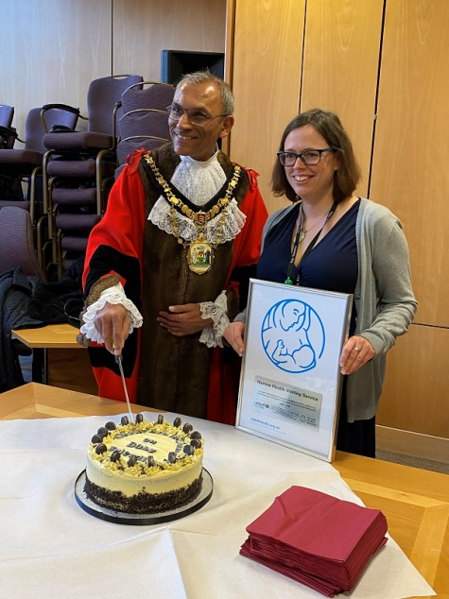Participation in tai chi twice a week is shown to improve balance, strength and prevent falls aswell as providing a positive way to socialise. Public Health is supporting free Tai Chi provision in Harrow – looking at ways we can promote the benefits of Tai Chi and make sure people know about the sessions.

## Breast feeding

The award ceremony to celebrate the service’s achieving reaccreditation with the UNICEF Baby Friendly Initiative Level 3 was recently recently took place. The Infant Feeding Lead for Harrow was presented with the award by the Mayor of Harrow.

## Vision screening in private primary schools

Working in conjunction with a concerned local parent the Director of Public Health has written to all parents / carers of pupils in private primary schools in the borough reminding them of the importance of taking their children for an eye test before the age of 6 in order to catch any amblyopia (commonly known as “lazy eye”) while it is still treatable. Left untreated, it can lead to the eye's central vision never reaching normal levels.

Each borough’s self-assessment will be reviewed and then challenged in groups of 5-6 boroughs. Harrow will come together with Bexley, Kingston, Merton, Richmond and Wandsworth in late March undergo a rigorous peer review process in March 2020.

## Expert Patient Programme

In England, 15 million people are living with a long term health condition. 1 in 3 of the working age population have at least 1 long-term condition and 1 in 7 have more than one condition ([PHE Health Matters Jan 2020](https://www.gov.uk/government/publications/health-matters-physical-activity/health-matters-physical-activity-prevention-and-management-of-long-term-conditions)) People with 2 or more long-term conditions are more likely to be obese, eat less healthily and smoke, than people with one or none of these conditions (Maskell 2007, Scottish Government 2007). As the population continues to age, the number of people with long-term conditions is expected to increase.

There is a strong body of evidence that demonstrates that supporting people to manage their LTC is more effective than the conventional medical model, with benefits for people’s attitudes and behaviours, quality of life, clinical outcomes symptoms and use of healthcare resources (Lorig et al 2001). According to research,s people who have trained in self-management tend to be more confident and less anxious (Lorig et al 2001). They make fewer visits to the doctor, can communicate better with health professionals, take less time off work, and are less likely to suffer acute episodes requiring admission to hospital (Lorig et al 1999).

A DoH study shows that people with LTCs in London are the least likely to play an active role in treating their condition all or most of the time, with just 70% saying this compared to at least 83% elsewhere in the country ([Department of Health, April 2011](https://assets.publishing.service.gov.uk/government/uploads/system/uploads/attachment_data/file/215340/dh_130806.pdf)).

In Q3 Public Health Harrow re-launched the Expert Patient Programme (EPP) in the borough (after almost a 2 year break), which is being offered free of charge to Harrow residents and council employees. EPP supports the joint health and wellbeing strategy priorities for the age well life cycle (social isolation and loneliness, support for carers; frailty and falls; and management of LTCs).

EPP is a course for adults with LTCs (and/or carers) that teaches participants a tool kit of self-management techniques in order to maintain or enhance their health and well-being as well as their clinical, emotional and social outcomes. The programme encourages participants to take responsibility for their own health and wellbeing, making self-management a fundamental part of their every day lives to support their independence, promote self worth and to maintain their ability to lead as active a life as possible. Participants are encouraged to maintain contact with the peers from their cohort once the course has been completed, to continue to support each other, keep them engaged with the programme and to embed learning. They are also provided with a self-management text book containing all of the information (and more) provided on the course. Key topics include: dealing with pain, fatigue and extreme tiredness; dealing with difficult emotions; communication with health care professionals; medicine management; fall prevention; healthy eating; exercise; weight management; problem solving; decision making and others.

The first 2 courses were delivered in Q3 with a further course to take place in Q4 of this financial year. Cohort sizes are between 8 and 16. We expect to commission a minimum of 4 courses per year thereafter, providing places to 64 residents who can self refer. As a new service we will be closely monitoring the programme for efficacy and uptake.

Participants from the first 2 cohorts have said that they had “given up” before attending [EPP] and that it helped just to be in a room with people who genuinely understood. One participant and their carer wrote “[We] are not backward in doing many of these things already but struggling with long term conditions does wear anyone down. One can get to feel that the condition is in charge. The course is an excellent antidote.” Personal achievements and feedback reported have included: started painting again; created crystal cards for mindfulness; went cycling for the first time in 1 year and rode 6 miles; started cooking again; I realised that “I matter”; I’ve been able to help other people; I’ve been able to say “No”; I’ve learnt to put myself first. Some participants have also sought advice from their peers about returning to work with a LTCs and how they overcame the barriers that their LTC causes.

During Q3 we have also been working to promote the programme, producing a PowerPoint presentation for GP waiting rooms, distributing posters and leaflets to GPs, pharmacies, libraries, children’s centres and community organisations. We have had a positive response from the community and uptake is increasing. We are currently building relationships with Adult Social Care and looking at ways that we can create pathways and streamline the referral process for service users who have been referred to the Early Intervention and Prevention Team.

# Commissioned Services

## The Children and Young People Sector Led Improvement

The Association of Directors’ of Public Health in London has made 0-19 services in London the focus of this year’s Sector Led Improvement programme. This is where all boroughs have to complete a self-assessment return. A stakeholder workshop was held on 2 Dec 2019 which was very good for engaging colleagues from across Harrow on a number of cross-cutting issues. Participants were very supportive of both health visiting and school nursing and were particularly interested in oral health and speech and language.

## 0-19 Service

### Health Visiting

The service has continued to improve performance. Of particular note is the highest ever percentage of children receiving a 6-8 week review (97%) and the two-year review figure (93%) surpassed that of last quarter. The service has been using staffing underspends on substantive posts to pay overtime for staff to work at weekends. This has made it easier for working parents/carers to attend reviews.

The work with the Romanian community continues to develop. A brochure in Romanian is being produced setting out the role of the health visitor and how the health system in England works i.e. trying to emphasise the importance of seeing the health visitor or calling 111 (where they can access Romanian interpreters) before going to A&E. This work was also informed by a Serious Case Review and has underlined how useful it is to have the Designated Nurse always attending the contract monitoring meetings.

As can be seen from the next table, performance has been improving across the board.

### cid:image004.jpg@01D5DC20.550BAB70School Nursing

Three schools now have asthma friendly status and 40 out of the 62 Harrow schools have requested that the service deliver health promotion sessions. The service is seeking to make sure that all schools take up the offer by the end of the academic year.

The service has continued to forge closer links with parents / carers who electively home educate their children. This is a group that can easily be overlooked and it is very pleasing to see that the school nursing service is starting to build the trust with this community.

## Substance Misuse Services

### Compass Harrow Young People’s Substance Misuse Service

Currently 110 young people in Harrow are receiving treatment for their substance misuse. This care will always be part of a wider support network of relevant care agencies around the young person. As part of ‘teach and deter’ area of their work, Compass have also delivered outreach/presentations during this quarter in a variety of settings across Harrow including: School Nursing Service, Shaftesbury High School Parents’ Evening (drug awareness) and Y11 (drug awareness, knife crime and gangs workshops), Harrow College Safety Fair, Park High School Yr13 (PSHE Presentation), Grange Farm (Youth Violence meeting)

Referrals into Compass from Education are significantly higher than those from the Youth Offending Service – this is seen as a positive trend as it may indicate that young people are receiving support for their substance misuse at an earlier stage before becoming involved in the Criminal Justice System.

### WDP Harrow Adult Substance Misuse Service

A new service specification reflects the latest UK guidelines on clinical management of drug use & dependence and new PHE data including prison transfers into community treatment. The document has informed a refreshed treatment and recovery pathway followed by an Invitation to Tender for the new Service to commence on 1.4.20. The outcome of the procurement will be published in Q4.

To continue to support the drive of the London Joint Working Group on Substance Misuse and Hepatitis C Virus (HCV), WDP have reinforced their joint working with the Hepatology Unit at Northwick Park Hospital to revise the ‘testing to treatment’ pathway including a failsafe mechanism to review service users who decline a HCV test or referral to treatment. The joint working arrangement also includes a Hepatology ‘in reach’ clinic to the Substance Misuse Service which incorporates a fibroscan (to measure the degree of damage to a liver) for assessed service users and for those who may be a risk of liver damage but are not exhibiting symptoms.

## NHS Health Check programme

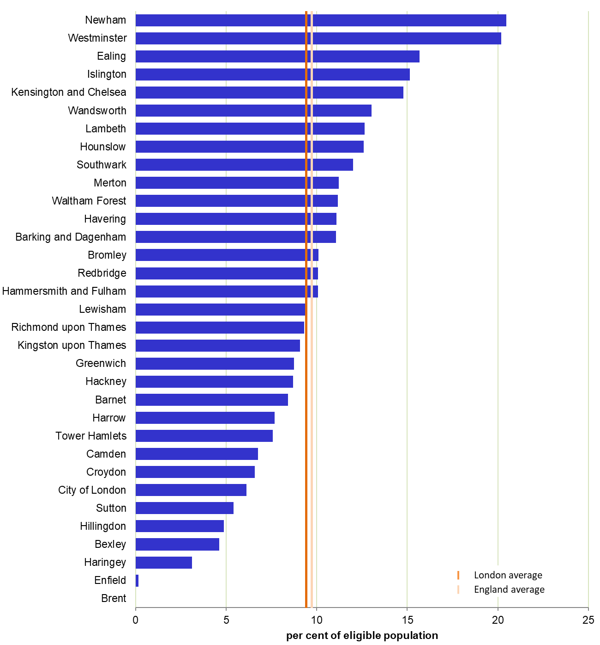The numbers of NHS Health Check invites and completed checks is below what we are expecting in order to achieve the 20% target. The larger practices have proven very difficult to engage with. The Public Health Commissioner has been visiting all the main underperforming practices. The reasons for not engaging vary but the main reason cited is the reduction in the amount the practices receive per completed NHS Health Check from £25 to £20. Performance has also been hampered by the extended leave of one of the provider’s key staff members.

Public Health has had to write a letter to PHE London explaining our reasons for the underperformance over five years and the plan to improve it. Overall Harrow was 23rd in London for NHS Health Checks performance for the first two quarters of the financial year:

The focus remains increasing the number of invitations, increasing uptake of NHS Health Checks and improving data quality so that it is easier to measure impact.

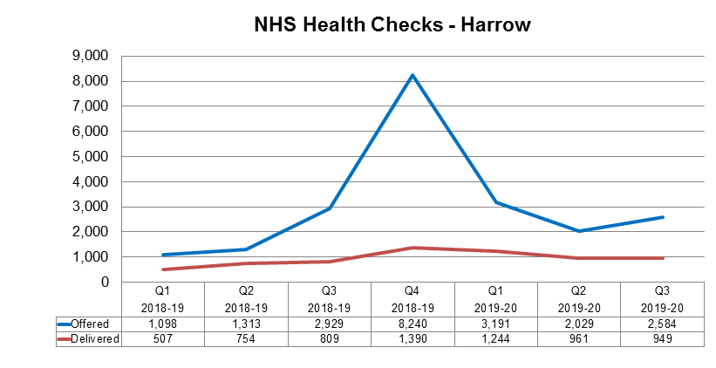

The following graph shows Healthcheck performance by GP practice with cumulative activity data for Q1 – Q3 2019-20.

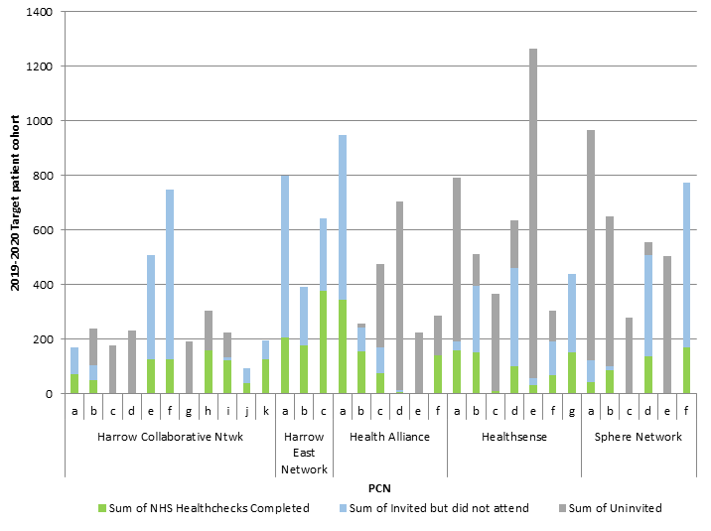 The grey part of the chart shows practices that are under-inviting. Some practices are currently overinviting which we are allowing them to continue to do. As the programme continues this will not be sustainable and it will put into greater focus the need to encourage the non-engaging practices to start offering the programme.

## Integrated Sexual & Reproductive Health Service

The new integrated service at Caryl Thomas Clinic is now fully embedded and supported by the sexual health outreach service with a particular focus on HIV prevention and testing. The London Sexual Health Partnership work continues with the Harrow Commissioner representing the outer North West London boroughs of Harrow, Brent and Ealing. There continues to be emphasis on the re-direction of clients requiring testing with no symptoms to the e-Service and Harrow has seen an increase in returning users to the site.

# Health Protection

## Health Protection Forum

We have established a local Health Protection Forum for Harrow. The purpose of the forum is to provide a single, integrated approach for those agencies involved in health protection and emergency preparedness, resilience and response. It will look at immunisation, annual flu programmes, infection control, disease outbreaks, public health aaspects of emergency planning and pandemic flu preparedness. The first meeting was in September and it will be held quarterly.

## A Focus on Flu

October is the beginning of the flu campaign. In addition to promoting the flu campaign and sending resources out, we also recognised the potential impact of our staff on the transmission of flu to the vulnerable people they come into contact with. We publicised the need for flu jab amongst council staff and organised flu jabs sessions which was delivered by a local pharmacist. As a result of these sessions, we were successful in immunising over 100 council staff from across the council. Flu is one of the topics covered by our health protection forum.

# In the next issue

We will be looking at the outcomes of health checks programme in more detail next quarter.